**NAME:P V NAVI KISHORE**

**REG.NO.:192111220**

**CODE:CSA1366**

**LAB WITH SIMULATOR**

**EXPERIMENT:1**

**AIM:** TO DESIGN DFA TO ACCEPT bcaaaaaaaaaaaaaa,bc andc.

**SOFTWARE REQUIRED:**

* **Auto simulator**

**PROCEDURE:**

1. Open the simulator and enter DETERMINANT FINITE AUTOMETA for new file.
2. Place two stages and mention the final state.
3. Join the stages with edges and give the direction for each edge.
4. Enter the inputs and simulate.

**INPUT**:

bcaaaaaaaaaaaaaa,ba,c

**DESIGN AND OUTPUT:**

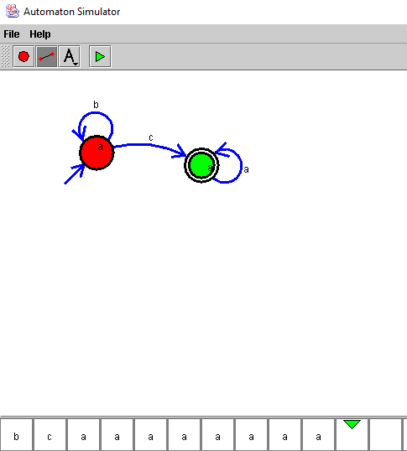

**RESULT:** Therefore the autometa DFA accepts the inputs bcaaaaaaaaaaaaaa, bc, c.